Addiction: After taking a drug the player must make a save. A failed save means problems:

Take once Habituated (require 1/day)
Take again while habituated Addicted (require 3/day)
Take again while addicted Overdose (save or Die)

Withdrawal: If a player can't take the needed number of doses while habituated/addicted they suffer a penalty to all die rolls
equal to the drug's withdrawal number. Once in withdrawal save or attempt to take any doses around.

Overdose: Taking extra doses while still under the effect of the initial hit will lead to effects in the table below.

Kicking the Habit: Going without a hit for a month & making a save, or becoming habituated to a new drug will cure an addiction.

Roll | Drug | Local Name | Effect | Duration | 2 Doses | 3+ Doses | Withdrawal
  1 | Chill |  | +2 to saves vs fear/panic, last on initiative | 1d6 hrs | Paranoia | Stunned | +1
2 | Down |  | Sleep well regardless of conditions, difficult to wake | 1d6 hrs | Coma | Death | +1
3 | Fast |  | Always first, 2x attacks with one-handed weapons | 1d6 hrs | Dizziness | Death | +3
4 | Lewd |  | Attraction, save or proposition likely targets | 1d6 hrs | Rash | Nausea | +2
5 | Numb | Black Orchid | Ignore pain & damage | 1d6 trns | Unconscious | Death | +4
6 | Rage |  | Save or berserk during violence, no morale checks | 1d6 hrs | Joint Aches | Death | +3
7 | Sharp |  | Bonus to spot traps, secret doors, ambushes | 1d6 hrs | Headache | Unconscious | +2
8 | Strong |  | 2 dice for damage take highest, +2 to open doors, etc | 1d6 hrs | Nausea | Death | +3
9 | Trip |  | Aggression down, visions may reveal future or answers | 1d6 hrs | Fear | Madness | +1
10 | Up |  | Function as normal though tired, hungry, or sleepless | 1d6 hrs | Diarrhea | Death | +2
Known Drugs
1 | Kilhuactl, Orc Phallus | Rage, Strong, Trip | 1d6 trns | All | Unconscious | +1
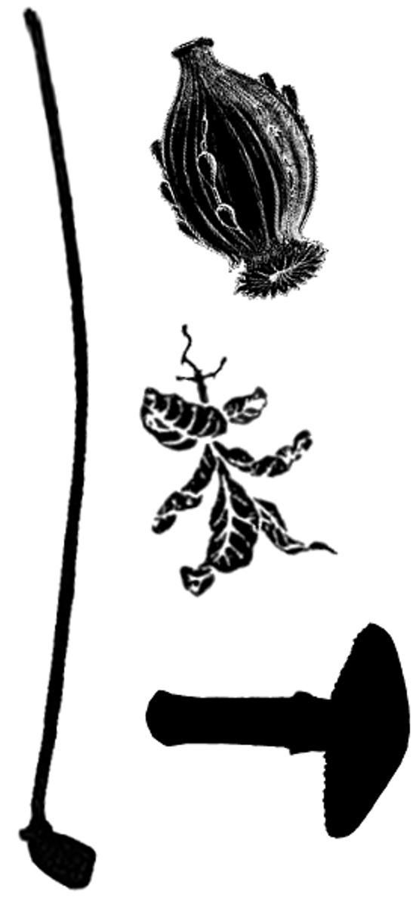  2 | Deep Leaf | Down, Trip (visions while sleeping) | 1d12hrs | Coma | Death | +1
3 | Kings Eye, Dog | Lewd, Sharp | 1d6 days | Rash | Dizziness | +3
4
5
6
7
8

Addiction rules by Chris Hogan - http://vaultsofnagoh.blogspot.com

